EXPERIMENT 4 A

EXPLORATORY DATA ANALYSIS (EDA) – DATA INSPECTION, FILTERING, STATISTICAL ANALYSIS AND CORRELATION

Aim
To perform data inspection, filtering, grouping, aggregation, descriptive statistical analysis, and correlation analysis using Pandas and visualize the results using Matplotlib.

Sample Dataset

Diabetes Patient Dataset
ID | Age | Gender | Glucose | BMI | HbA1c
101 | 25 | Female | 110 | 22.5 | 5.4
102 | 45 | Male | 145 | 27.8 | 6.5
103 | 52 | Female | 160 | 30.2 | 7.2
104 | 38 | Male | 130 | 25.4 | 6.0
105 | 60 | Female | 180 | 32.1 | 8.0
106 | 48 | Male | 155 | 29.5 | 7.0

Algorithm 1 - Dataset Inspection

Step 1 - Import Pandas library.

Step 2 - Create the diabetes dataset.

Step 3 - Display the dataset.

Step 4 - Check dimensions.

Step 5 - Display data types.

Program 1

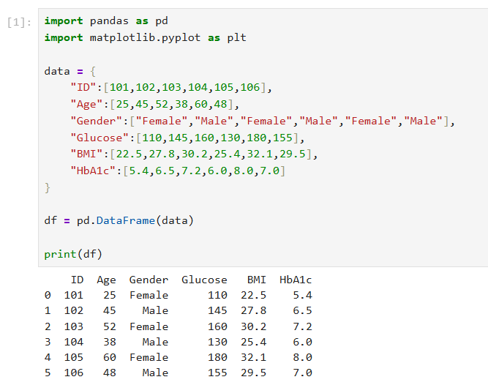

Program 2 - Shape of Dataset
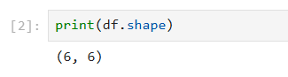

Program 3 - Data Types

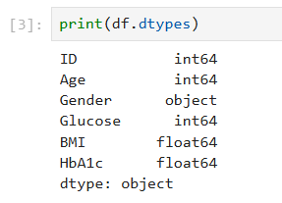

Algorithm 2 - Filtering Data

Step 1 - Specify condition.

Step 2 - Apply filter.

Step 3 - Display records.

Program 4 - Patients With Glucose More Than 150

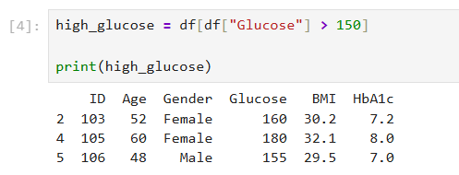

Program 5 - Patients With HbA1c More Than 6.5
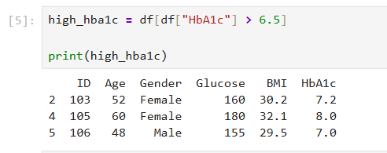

Algorithm 3 - Sorting Data

Step 1 - Select column.

Step 2 - Apply sort_values().

Step 3 - Display sorted result.

Program 6 - Sort Glucose in Descending Order

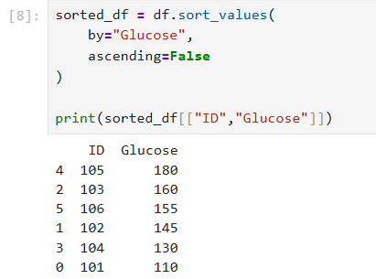

Visualization - Glucose Level Ranking

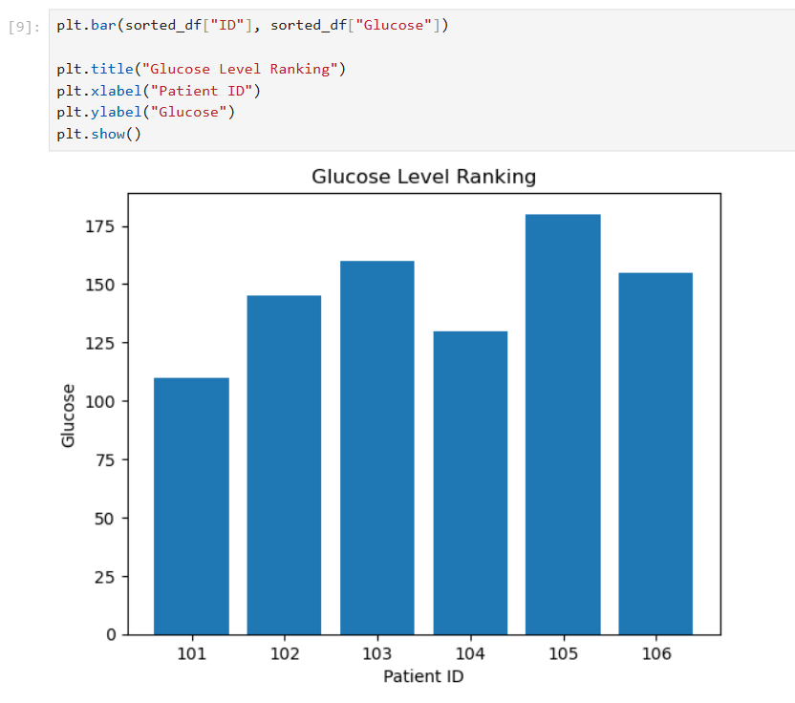

Algorithm 4 - Statistical Analysis

Step 1 - Select numerical column.

Step 2 - Calculate Mean.

Step 3 - Calculate Median.

Step 4 - Calculate Mode.

Step 5 - Calculate Standard Deviation.

Program 7

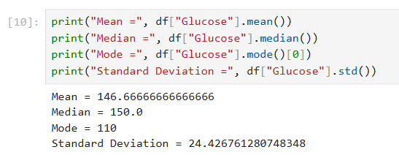

Program 8 - Descriptive Statistics
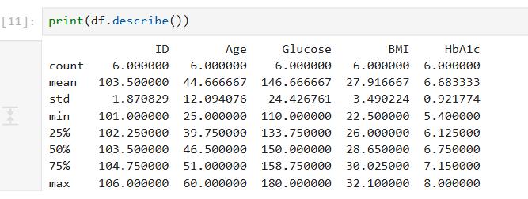

Algorithm 5 - Grouping and Aggregation

Step 1 - Select Gender column.

Step 2 - Apply groupby().

Step 3 - Calculate average glucose.

Step 4 - Display result.

Program 9

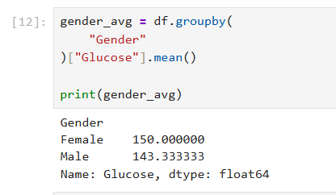

Visualization - Gender-wise Average Glucose

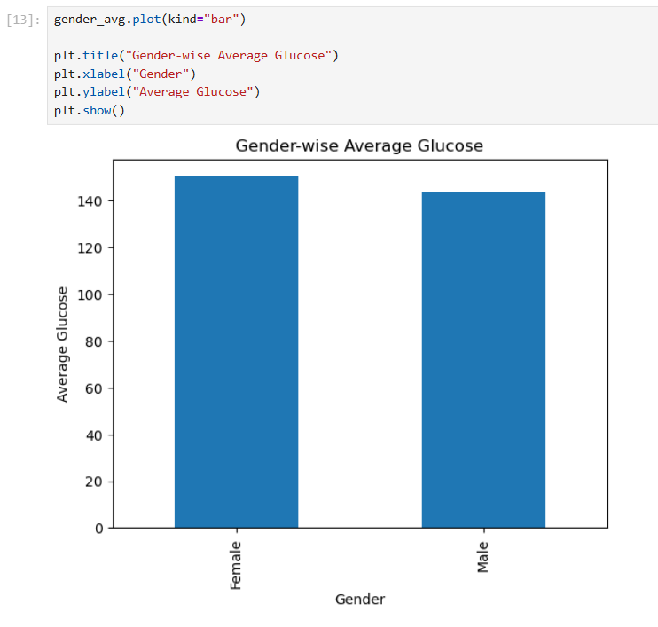

Algorithm 6 - Correlation Analysis

Step 1 - Select numerical columns.

Step 2 - Apply corr().

Step 3 - Interpret correlation coefficient.

Program 10

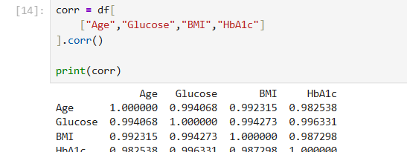

Result
Thus, Exploratory Data Analysis (EDA) was successfully performed on the diabetes patient dataset. Data inspection, filtering, sorting, statistical analysis, grouping, aggregation, correlation analysis, and visualization were performed using Python, Pandas, and Matplotlib.

